Caves, Karst and Cahokia’s Religious Origins

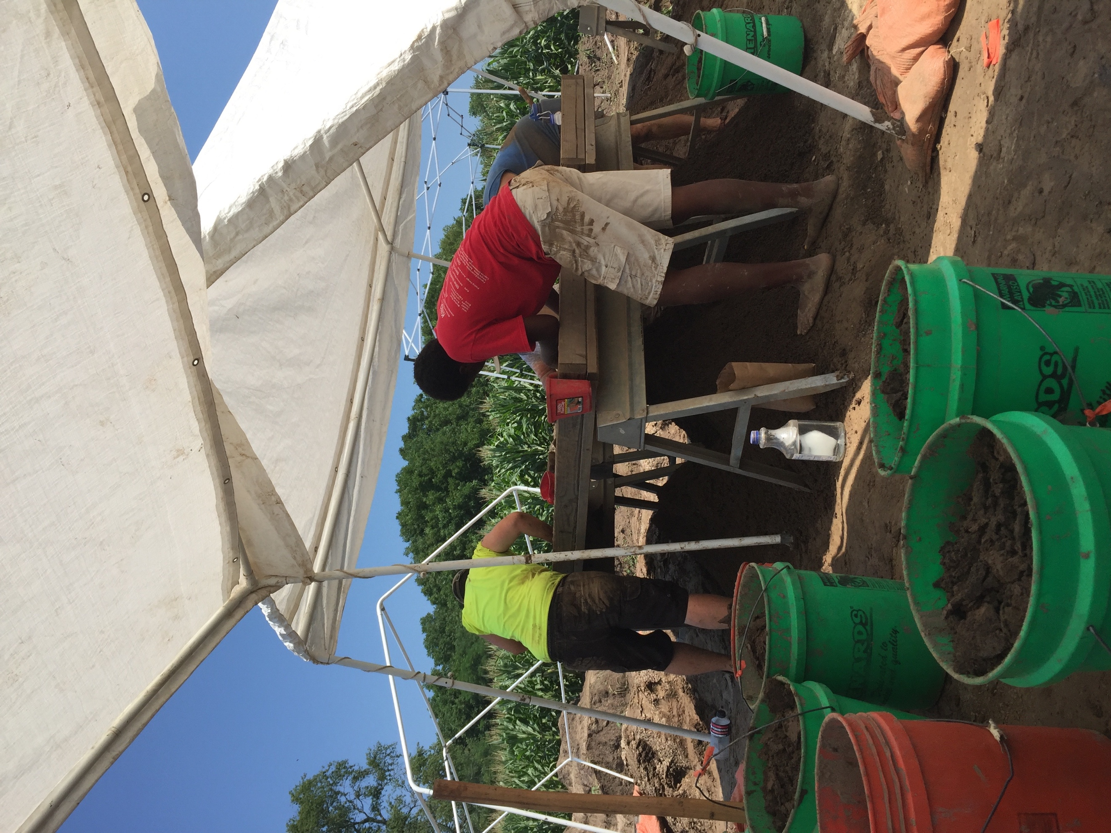
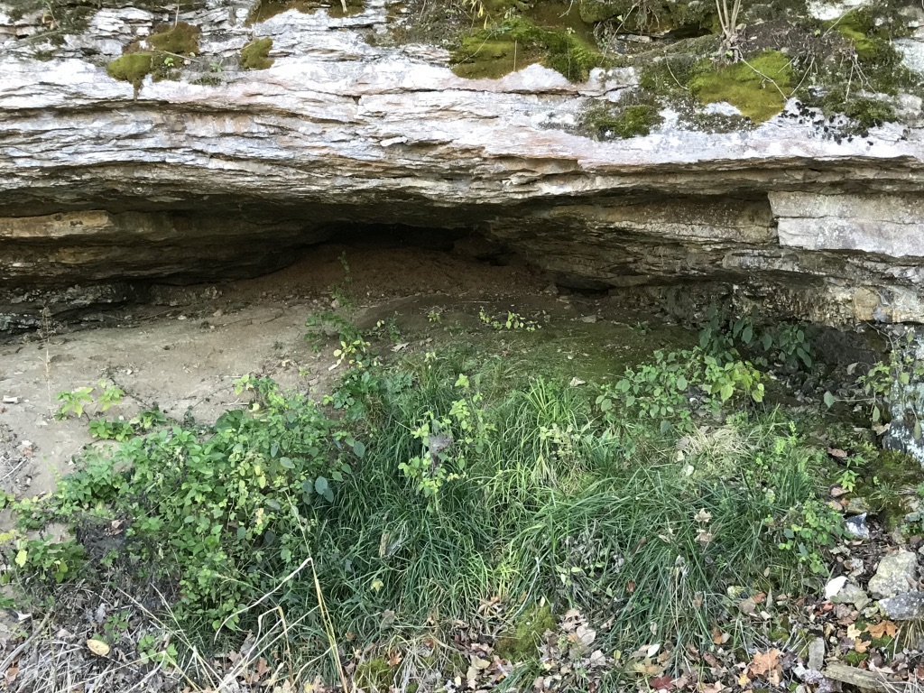
Anth X 480
6 credits
2019 Indiana University
Field School in Archaeology
Dr Susan Alt
June 1-July 13th
Lebanon Illinois

In this year Midwest archaeological field school students will fully participate in original research and discovery while learning how responsible archaeology is conducted. No previous experience or knowledge of archaeology is required to participate in this program. You will learn the hows and whys of archaeology as the course progresses.

This year’s Midwest field school has two goals: we will investigate the relationships of caves and karst to the religious beginnings of Cahokia, Native North American’s only pre-Columbian city, and we will excavate house basins and storage features at a pre-urban Cahokian town to explore how a new Cahokian religious movement affected the day to day lives of pre-Columbian farmers. Students will learn how to excavate, map, and document features as well as participate in archaeological survey and the documentation of a mound site and cave in Missouri.

Students will share apartments/duplexes in Lebanon Illinois and work daily at our research tasks. Lectures and discussions will be held during our group dinners in the evenings.
You will learn: survey, and be introduced to Magnetometry, GPS, and mapping with a Total Station.

You will learn: feature excavation as well as feature and profile mapping by digging 1000 year old houses and pits.

You will meet and enjoy lectures from top Midwest archaeologists and visit their field sites.

You will learn how responsible archeology is conducted by working with multiple institutions and communities.

Weekends are yours, visit St Louis, and enjoy local entertainment—visit Museums, Parks, Shopping, or Six Flags!

APPLICATIONS: Available in SB036, or SB054, or email susalt@indiana.edu
After fieldwork ends, there will be opportunities for students to continue to study and earn course credit for lab analysis, student projects and honors projects. Student participation in professional presentations and public education will be encouraged! Housing Provided: Fee is expected to be about $ 400

FOR INFORMATION CONTACT: Dr. Susan Alt susalt@indiana.edu See previous digs on facebook: https://www.facebook.com/groups/393101914060463/ or as seen on the PBS series Native America episode 3.

Caves, Karst and Cahokia’s Religious Origins
Indiana University Bloomington
2019 Field School in Archaeology
Dr. Susan M. Alt
Anth X 480 6 CREDITS
DIRECTIONS. This form can be completed and submitted in person to Dr Susan Alt in office SB 036 or SB 054 (lab) by March 15, 2019. Applicants may also send completed electronic versions to susalt@indiana.edu.

Name___________________________________________________________________________________________

Street Address______________________________________________________________________________________

Spring Semester Phone and E-mail______________________________________________________________________

Academic Status (circle): freshman sophomore junior senior grad. Other_______________________________________

Major/Overall Grade Point Average_____________________________________________________________________

Why take field school?

Extent of your past outdoor work experience_____________________________________________________________

List abilities/qualities you can offer the Project____________________________________________________________

VERY IMPORTANT: YOU MUST BE COVERED BY HEALTH INSURANCE PRIOR TO LEAVING FOR THE FIELD.

What health insurance will cover you in the summer?____________________________________________________

Identify any special considerations regarding your health, allergic conditions, and ability to engage in strenuous outdoor activity (this will not prevent your acceptance but alerts us how to help you)

Your signature here acknowledges your understanding that you will be an active participant in a special field course connected to a research project with goals above and beyond an ordinary on-campus college course. Fieldwork can be strenuous, days are often long (> 8 hours), and you may be required to work under uncomfortable weather conditions. Costs to take this class will be summer tuition, plus a $400.00 housing fee*. Transportation to and from field sites is the responsibility of the student (although carpooling is normal), as are the costs of your meals although costs are defrayed by group cooking.

Signature:

* There is no textbook required, readings will be placed on oncourse. Please note that students will be responsible for their own food and for purchasing personal excavation supplies (your dig kit costs between 50 and 75 dollars) to be used in the field. All other equipment is provided. No special clothing or equipment beyond your dig kit need be purchased. Additional information will be distributed following acceptance into the field school during pre -­‐field meetings. It is about a 3 1/2 hour drive to the field housing from Bloomington, and you will be free to drive home on weekends.
FOR Further INFORMATION CONTACT: Dr. Susan Alt susalt@indiana.edu

