Help SIUC archaeologists unearth the history of the Lewis and Clark Expedition in Illinois by exploring the remains of a fort lost for over 200 years!!!

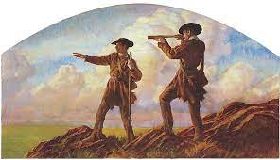

Seven years ago the SIUC Anthropology Department archaeological field school class (Anthropology 496/596) discovered the long-lost site of the American Ft. Kaskaskia where Lewis and Clark recruited 11 men for their 1803 expedition to explore the American West!!! We are looking for a further 11 or 12 recruits this year for the SIUC field school to help us recover additional information through archaeology on the daily lives of the Lewis and Clark men prior to their joining the expedition!

The archaeology field school is a six credit six week long (May 20-June 28) off campus course where students learn excavation techniques as well as working with remote sensing instruments such as ground penetrating radar (GPR). The field school cost this year is $1977.50. Academic and housing scholarships are also available. More details including an application form can be found at http://cola.siu.edu/anthro/undergraduate/field-school. or email your questions to Dr. Mark Wagner at mjwagner@siu.edu.

