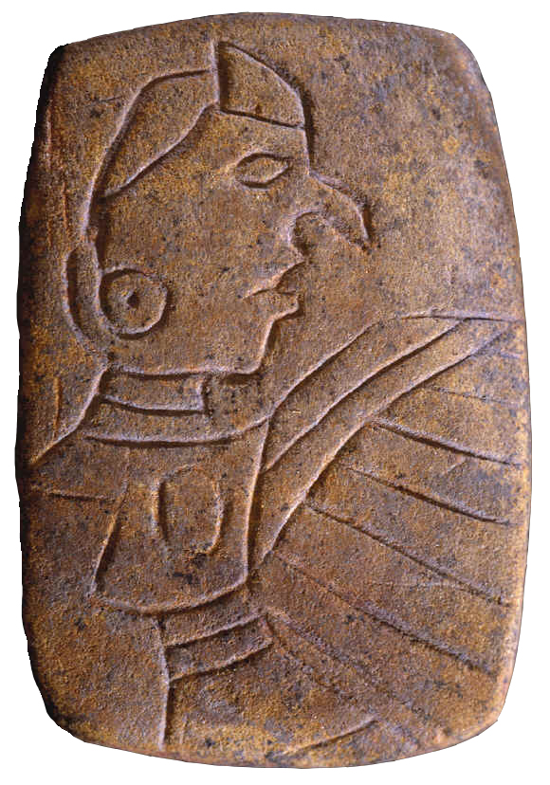 | Illinois Archaeological Survey  63rd Annual Meeting  Collinsville, Illinois  September 6–7, 2019

ADVANCED REGISTRATION FORM

Name: ______________________________________________________________________________________

Affiliation: _________________________________________________________________________________

_________ YES, I will attend the conference on Saturday, September 7, 2019.

_________ YES, I will attend the Welcome Reception at the Cahokia Mounds Interpretive Center including a complementary barbecue dinner, drinks, and dessert. Please indicate any dietary restrictions below:

_____________________________________________________________________________________________________

Send your completed form to Alleen Betzenhauser at betzenha@illinois.edu
by September 1st to RSVP for the reception

$5 Registration fee may be paid by cash or check (payable to Illinois Archaeological Survey)
on site or mailed to

Dan Amick
IAS Treasurer
1851 Sycamore St.
Des Plaines, IL 60018-2354

