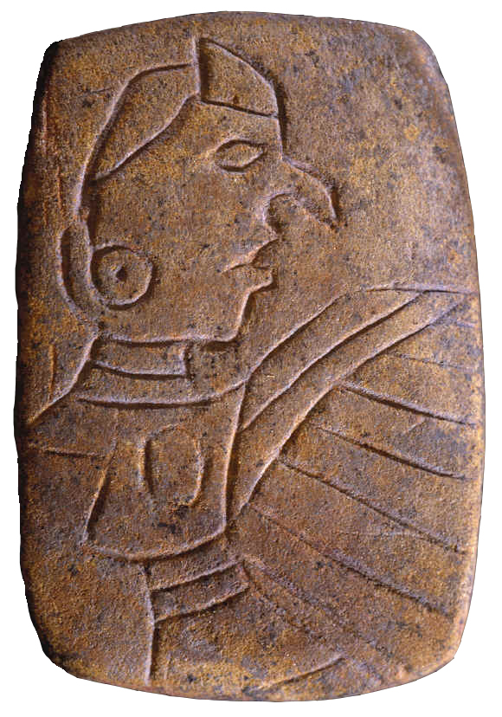 | Illinois Archaeological Survey  63rd Annual Meeting  Collinsville, Illinois  September 6–7, 2019

The 63rd Annual Meeting of the Illinois Archaeological Survey will be held in Collinsville, Illinois September 6–7. This year, the meeting will be hosted at the Cahokia Mounds State Historic Site. The meetings will include an evening reception from 6:30 to 9:00 p.m.,
September 6, at the Cahokia Mounds Interpretive Center (https://cahokiamounds.org/visit/#tab-id-4). The annual business meeting of the IAS will be held Saturday morning (September 7), followed immediately by paper and poster presentations at the Interpretive Center.

Advanced registration and abstracts are due by Friday, August 16th. You may register on site if you do not plan to present. There is a $5 registration fee to cover the cost of coffee and snacks. For advanced registration and/or to submit an abstract, please fill out the registration form and email to Alleen Betzenhauser at betzenha@illinois.edu. Make checks payable to Illinois Archaeological Survey for the $5 registration fee and mail to:

Dan Amick
IAS Treasurer
1851 Sycamore St.
Des Plaines, IL 60018-2354

Lodging Information

We have a block of rooms at one hotel in Collinsville, although there are several other options available within 5 miles of Cahokia and in St. Louis, MO. The room block is at the Drury Inn, which is located on Bluff Road (IL 157) near Interstates 55/70/255 and 4 miles from Cahokia. These rooms will be available for $88/night until Tuesday, August 13th. The room includes hot breakfast and evening snacks and drinks. Mention the group name, Illinois Archaeological Survey or Group Number (2387320), when you make your reservation by phone or online. MAKE YOUR RESERVATIONS BY AUGUST 13, 2019 TO GET THE REDUCED RATE!

Drury Inn
602 North Bluff Road (IL 157)
Collinsville, IL 62234
800-325-0720
druryhotels.com
Group Name: Illinois Archaeological Survey
Group Number: 2387320

Illinois Archaeological Survey
63rd Annual Meeting

Collinsville, Illinois
September 6–7, 2019

Meeting Schedule

Friday, September 6

6:30–9:00 IAS Reception sponsored by the Cahokia Mounds Museum Society, the Department of Anthropology at Southern Illinois University, Edwardsville the Department of Anthropology, University of Illinois, Urbana–Champaign, and the Illinois State Archaeological Survey – Interpretive Center Lobby and Auditorium
Complementary barbecue (https://www.beastcraftbbq.com), beer, and other beverages, sides, and desserts will be provided. Enjoy an augmented reality demonstration presented by the Illinois State Archaeological Survey based on recent research at the Emerald Acropolis.

Saturday, September 7

Registration 7:30–8:30 am – Interpretive Center Lobby
Annual IAS Business Meeting 8:00–9:00 am – Interpretive Center Auditorium
Paper/Poster Presentations 9:00–4:00 – Interpretive Center Auditorium
Lunch on your own 11:40–1:30
Paper/Poster Presentations 1:30–4:00 pm – Interpretive Center Auditorium

If you have any questions, contact Alleen Betzenhauser (betzenha@illinois.edu) or
Bill Iseminger (cahokia.mounds@sbcglobal.net).

